ASSIGNMENT 9.3
ENROLL NO:2403A52101
Task Description#1
- Paste a function with a missing colon (add(a, b)), and let AI fix the syntax error.
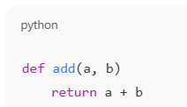

Expected Output#1
- Corrected function with syntax fix
- 
 